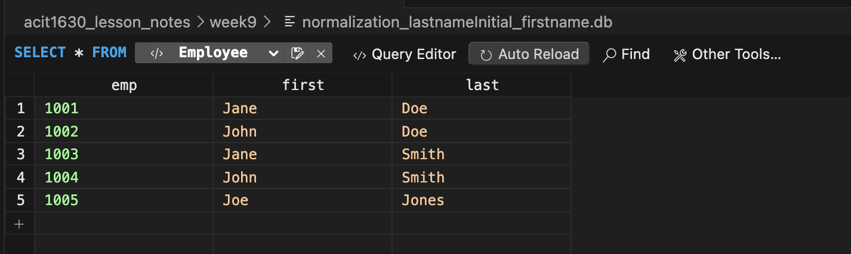
01 (a) normalization_FNF_employees
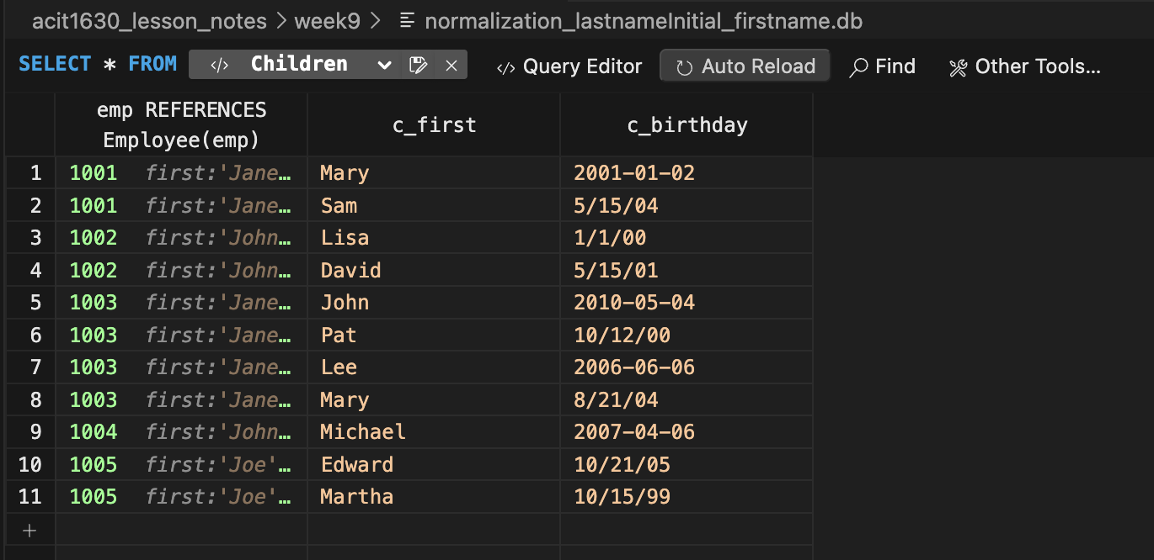
01 (b) normalization_FNF_children

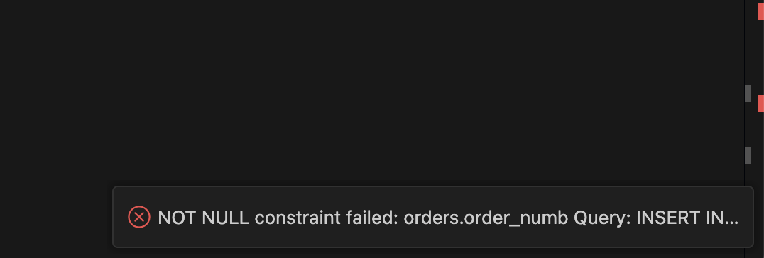
02_normalization_insertion_error1

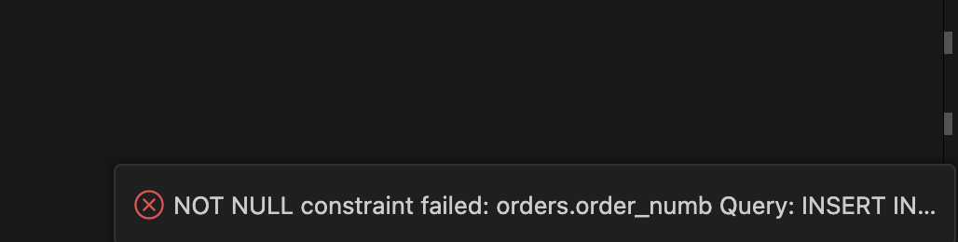
03_normalization_insertion_error2

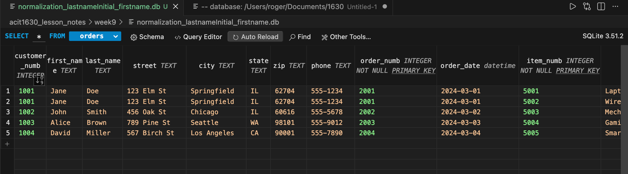
04_Orders_insertion

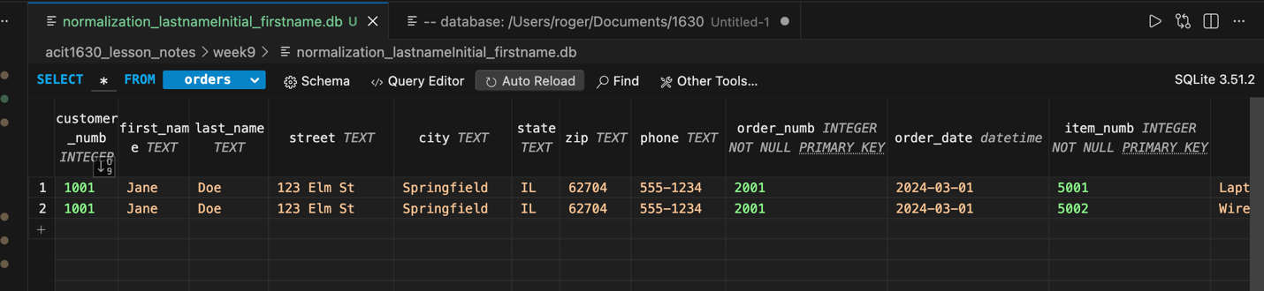
05_normalization_deletion_anomaly

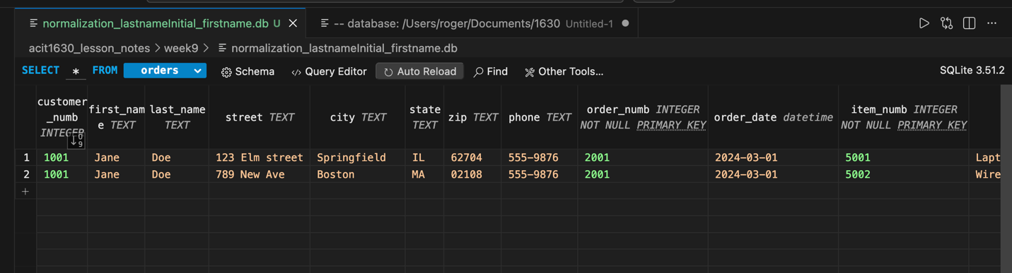
06_normalization_update_anomaly

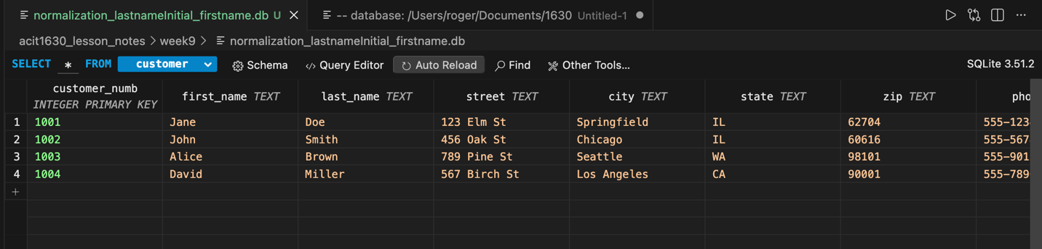
07(a)_normalization_2NF_Customers

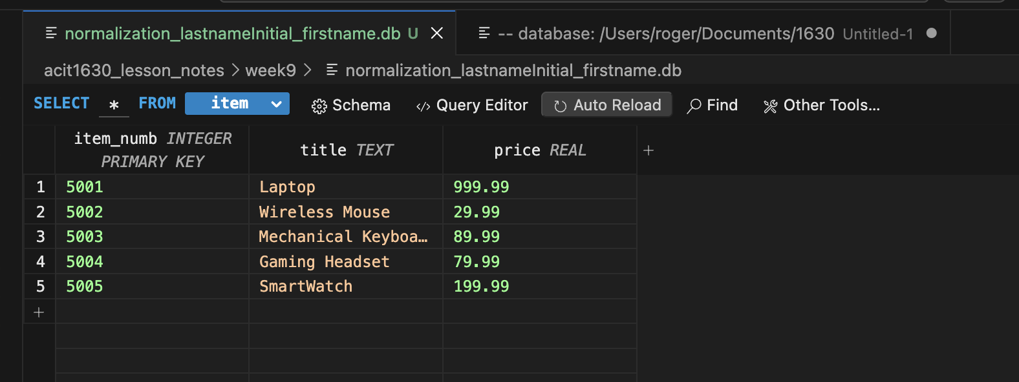
07(b)_normalization_2NF_Items

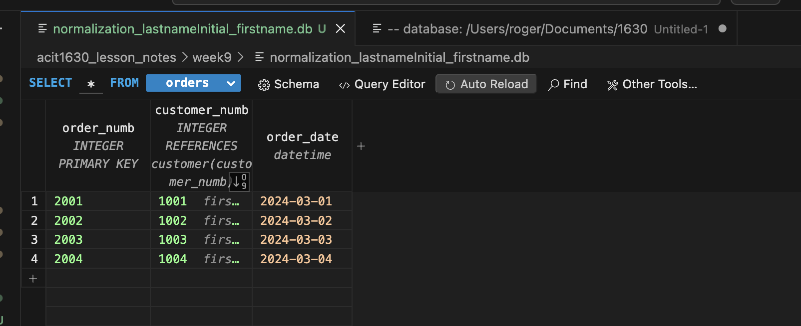
07(c)_normalization_2NF_Orders

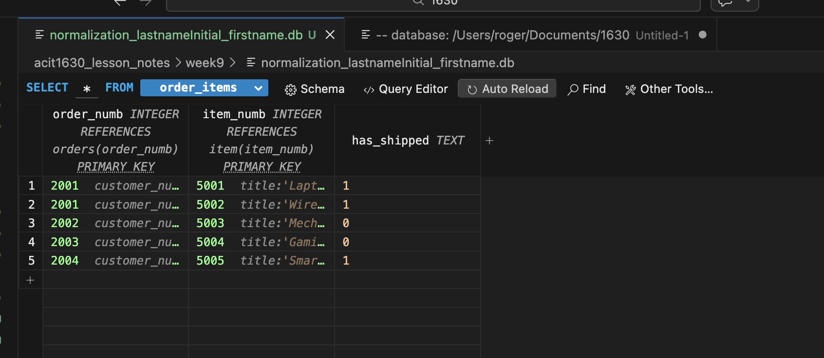
07(d)_normalization_2NF_OrderItems

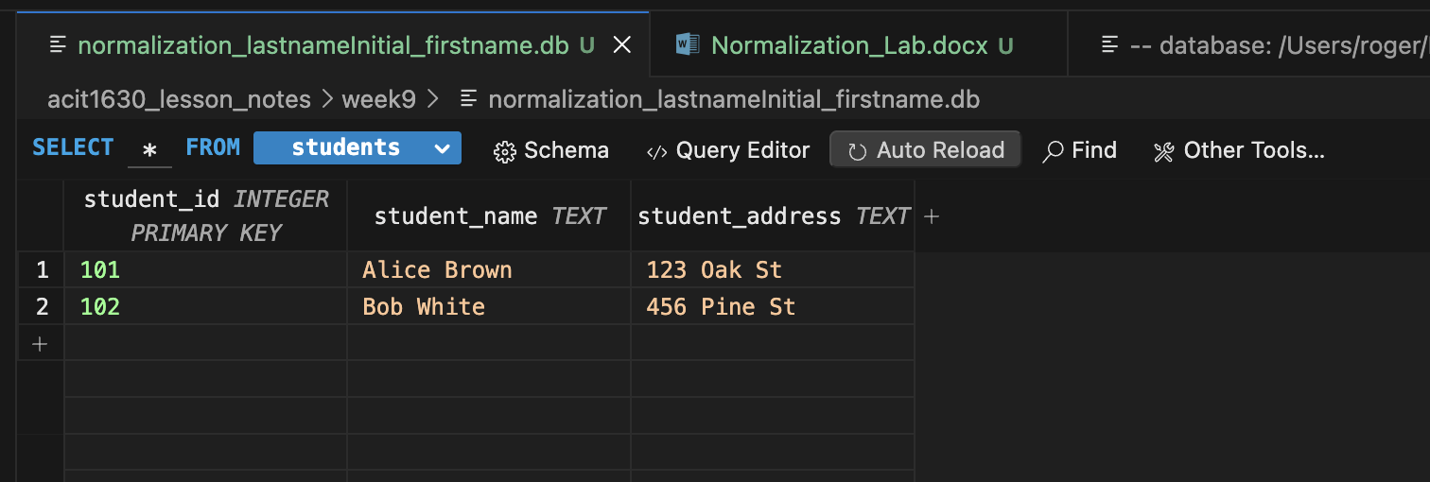
08(a) – normalization_3NF_Students

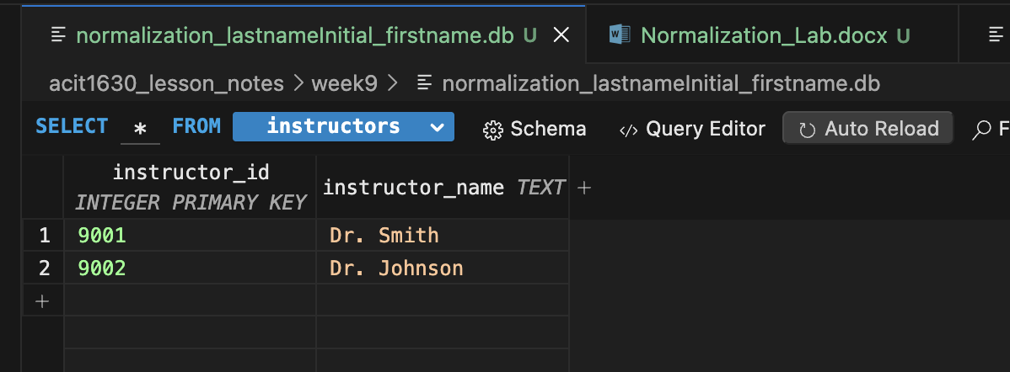
08(b) – normalization_3NF_Instructors

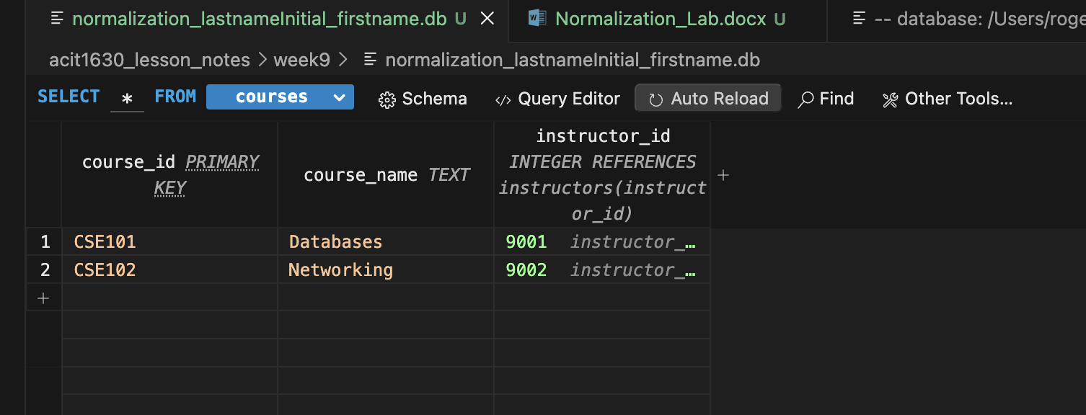
08(c) – normalization_3NF_Courses

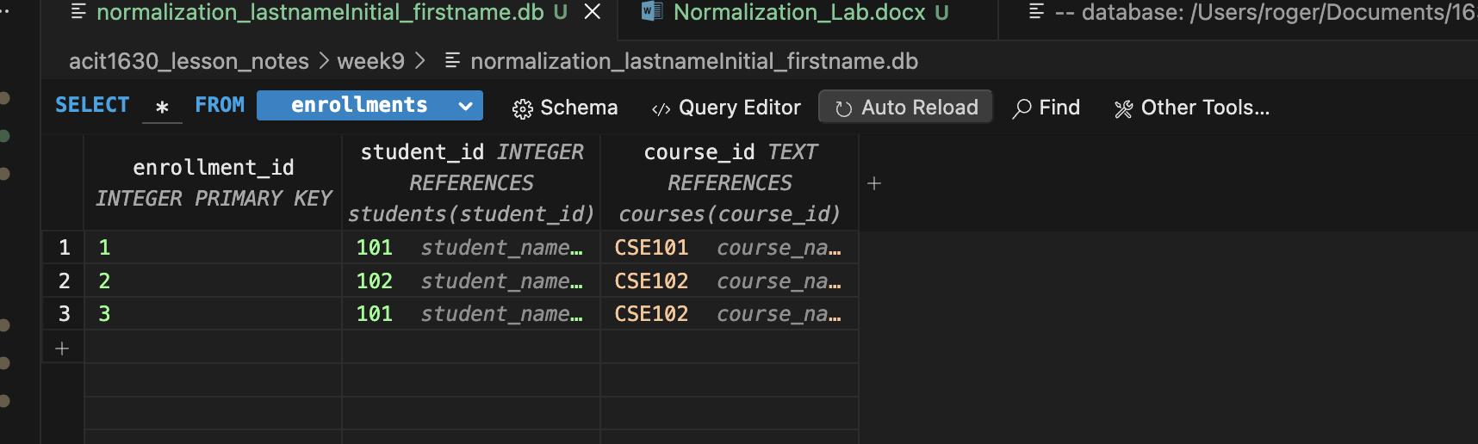
08(d) – normalization_3NF_Enrollmenments

